
Workday Implementation Services

Proposal for Greenpeace
February 2026

Table of Contents
1. Executive Summary 3
2. Our Understanding of Scope 4
3. Proposed Approach 6
4. Implementation Methodology and Delivery Plan. 10
5. Assumptions, Dependencies, and Exclusions. 13
6. Proposed Governance and Team Structure 15
7. Expectations for Greenpeace Project Team 21
8. Commercials 22

Executive Summary

Thank you for the opportunity to present Mivada’s proposal for Greenpeace Australia Pacific (GPAP).

We understand this ERP initiative is not simply a system replacement. It is a strategic step in GPAP’s Digital Transformation to consolidate fragmented platforms into a single, integrated, cloud-based ERP foundation that strengthens governance, improves operational efficiency, enables federation reporting, and provides an AI-ready data model.

The Problem: Fragmented Platforms = Fragmented Control
GPAP currently operates across multiple standalone systems spanning Finance, HCM, Payroll, Performance, Procurement, and reporting. While functional, this landscape creates:
- Disconnected data and manual reconciliation
- Limited cross-functional insight
- Governance and audit complexity
- Barriers to consistent reporting to Greenpeace International
- Integration challenges with Salesforce NPC and Data Cloud
When systems are not connected, automation weakens and decision confidence declines. This program is about restoring coherence across people, money, and procurement operations.

Why Mivada: Built for Operational Accountability
Mivada was born inside the customer, not built as a traditional consultancy.

We design ERP environments to operate reliably in business as usual, not just to reach go-live. Stability, auditability, and clean integration are treated as non-negotiables. Our approach ensures:
- Clear governance and decision velocity
- Configuration-led delivery with minimal customisation
- Secure integration with Salesforce
- Trusted, role-based reporting for Board and Leadership
- A structured data foundation capable of supporting Natural Language Querying and future AI capability
Our Proposal: Workday Launch, Phased and Fixed
We propose a Workday-led ERP implementation delivered using the Launch methodology, aligned to GPAP’s phased 2026 timeline
The scope includes:
- Core HCM and Recruitment
- Payroll (Australian and Pacific requirements)
- Core Financials including GL, AP, AR, and Banking
- Procurement foundations
- Integration with Salesforce NPC and Data Cloud
- Integration with Weel for corporate card automation
- Embedded reporting and analytics capability
Delivery is structured across two phases to establish a stable enterprise backbone before layering advanced capabilities.
De-Risking Delivery
To protect timeline and budget certainty, we apply three principles:
- Configuration over customisation to reduce complexity and long-term cost.
- The Data Handshake Model, ensuring iterative validation of finance and payroll data before production cutover.
- Governance designed for velocity, with clear escalation paths and structured decision tracking.

Our Understanding of Scope

Mivada understands that Greenpeace Australia Pacific (GPAP) is undertaking a strategically significant ERP transformation as a core component of its broader Digital Transformation program.

This initiative represents more than the replacement of legacy systems. It is an enterprise modernisation program intended to consolidate multiple standalone platforms into a single, integrated, cloud-based ERP solution that strengthens governance, improves operational efficiency, enables trusted cross-functional reporting, and provides an AI-ready foundation aligned to GPAP’s long-term strategy and federation obligations.

We also understand that GPAP seeks to:
- Replace SUN Financials, ELMO HR & Payroll, Paycor, Proactis, CultureAmp, and associated reporting solutions.
- Standardise and streamline core processes across Finance, People & Culture, Payroll, Performance, and Procurement.
- Reduce manual workarounds and fragmented data.
- Strengthen compliance, auditability, and governance controls.
- Enable integrated organisational metrics across ERP and Salesforce.
- Meet structured reporting obligations to Greenpeace International (GPI).
- Establish a scalable, AI-ready foundation aligned to its enterprise data strategy.

The ERP platform will form the enterprise backbone supporting financial management, workforce operations, procurement governance, and executive reporting.

Enterprise Platform Requirements
Mivada understands that GPAP requires a cloud-native, modular SaaS ERP platform delivered through a configuration-led
approach, with minimal customisation and strong use of out-of-the-box functionality

Key characteristics include:
- Low-code / no-code workflow capabilities to enable agility.
- API-first architecture to support integration.
- Role-based security, audit logging, and governance controls.
- Phased implementation aligned to the 2026 delivery timeline.

The selected solution must reduce total cost of ownership while increasing automation, transparency, and data integrity.

Coverage of In-Scope Functional Requirements
Mivada is prepared to provide comprehensive support across the full in-scope suite identified by Greenpeace. This includes, but is not limited to:
- Core HCM and Compensation
- Absence
- Recruitment
- Payroll
- Talent and Performance
- Financial Accounting​
- Banking & Settlement​
- Customer Accounts​
- Supplier Accounts​
- Budgets​

Integration and Delivery Expectations
Integration is a core pillar of this program and central to achieving GPAP’s objectives for a unified, modern enterprise platform. We understand that GPAP is seeking a phased, configuration-led implementation approach, underpinned by strong governance alignment, clear knowledge transfer, and a defined ongoing support model.

Mivada will design and deliver secure, scalable integration with Salesforce Nonprofit Cloud to support accurate income recognition and end-to-end reconciliation between fundraising and finance.We will also provide integration with Weel to enable seamless synchronisation of corporate card transactions and expense data into the ERP, supporting automation, financial control, and streamlined processing.
In addition to these core integrations, we can support further system integrations as required. We will work collaboratively with GPAP to define integration priorities and provide transparent pricing for any additional interfaces identified during the detailed design phase.

Summary
In summary, Mivada understands this ERP initiative to be a strategic transformation that will modernise GPAP’s enterprise platforms, standardise processes, strengthen governance, and enable integrated, AI-ready reporting across Finance, Workforce, and Procurement domains.

We recognise the importance of delivering a secure, scalable, and future-ready solution that supports GPAP’s operational model, federation responsibilities, and long-term digital strategy.

Proposed Approach
Mivada proposes a modern, cloud-native SaaS ERP platform designed to serve as GPAP’s integrated enterprise backbone across Finance, Human Capital Management, Payroll, Performance, and Procurement.
The proposed architecture is built on the following principles:
- Single Integrated Platform – Unified data model across finance, workforce, payroll, and procurement domains to eliminate silos and enable cross-functional reporting.
- Cloud-Native SaaS – Evergreen architecture with automatic updates, high availability, disaster recovery, and reduced infrastructure overhead.
- Modular Deployment – Phased rollout by functional domain aligned to GPAP’s 2026 timeline.
- API-First Integration Layer – Standards-based RESTful APIs and event-driven integration to enable seamless connectivity with Salesforce NPC, Data Cloud, Weel, and enterprise data platforms.
- Role-Based Security & Auditability – Granular access controls, workflow approvals, and audit trails to strengthen governance and compliance.
- AI-Ready Data Structures – Structured, governed data model aligned to analytics and Natural Language Query (NLQ) capabilities.
The architecture supports multi-entity operations, federation reporting, Australian compliance requirements, and Pacific payroll processing while aligning to GPAP’s broader digital and data strategy
Overview of proposed ERP platform and architecture.

Mivada proposes Workday as Greenpeace Australia Pacific’s unified, cloud-native ERP platform, designed to operate as the connected enterprise backbone across Finance, Human Capital Management, Payroll, Performance, and Procurement.
The architecture is based on five core principles:
1. Single Unified Data Model
Workday operates on a single object-based data model across people, payroll, finance, and procurement. This eliminates reconciliation gaps between modules and enables trusted cross-functional reporting.
2. Cloud-Native SaaS
Workday is delivered as evergreen SaaS with bi-annual releases, high availability, disaster recovery, and vendor-managed infrastructure. This reduces technical debt and total cost of ownership.
3. Modular, Phased Deployment
The platform supports phased rollout aligned to GPAP’s 2026 timeline, enabling core stabilisation before layering advanced capabilities such as Talent and Budgeting.
4. API-First Integration Architecture
Workday exposes secure REST and SOAP APIs, event-based notifications, and pre-built connectors. This supports integration with Salesforce NPC, Data Cloud, Weel, and federation reporting exports.
5. Role-Based Security and Auditability
Granular security domains, business process frameworks, and audit trails ensure compliance with Australian governance standards and federation reporting requirements.
The result is a secure, scalable enterprise backbone capable of supporting operational stability today and AI-enabled insight over time.

Description of out-of-the-box functionality vs configuration.

Mivada adopts a strict configuration-led delivery model aligned to Workday Launch principles

Out-of-the-Box (OOTB) Functionality
The majority of GPAP’s requirements are met through standard Workday capabilities, including:
- Core HCM and organisational structures
- Recruitment and onboarding
- Australian payroll compliance
- General Ledger, AP, AR, Banking
- Budgeting and financial reporting
- Procure-to-pay workflows
- Embedded dashboards and reporting
- Security, audit logs, and approvals
Workday’s business process framework provides configurable workflows without code.

Configuration (Not Custom Development)
Where tailoring is required, it is achieved through:
- Business process configuration
- Calculated fields and reporting logic
- Condition rules and validations
- Security role configuration
- Configurable review cycles for performance management

Custom development is avoided unless strictly necessary. This protects upgradeability, reduces long-term maintenance cost, and aligns with GPAP’s preference for minimal bespoke customisation

Approach to low-code / no-code implementation.

Workday is inherently low-code by design for the bulk of effort it is configuration only.
Mivada will leverage:
Business Process Framework (BPF)
Configurable approval chains, notifications, escalations, and workflow routing without code.
Calculated Fields & Reporting Builder
Advanced logic creation through point-and-click configuration.
Condition Rules & Validation Frameworks
Enforcement of governance and compliance without scripting.
Extend (where required)
If targeted extensions are required, Workday Extend enables low-code application development natively within the Workday security and data model, avoiding external silos.
This approach enables GPAP to maintain and adapt workflows internally post go-live without reliance on custom code.

Integration approach with Salesforce NPC and Data Cloud.

Integration between Workday and Salesforce is central to achieving GPAP’s objective of end-to-end visibility across fundraising, workforce cost, and financial reporting.

Our integration strategy is based on:
1. API-First Design
Workday will integrate with Salesforce NPC using:
- REST/SOAP APIs
- Workday Outbound Messaging (event-driven triggers)
- Secure middleware patterns where required
Key integration scenarios include:
- Income recognition alignment between Salesforce and Finance
- Donor revenue reconciliation
- Cost centre and program mapping
- Workforce data alignment for reporting
2. Data Cloud Alignment
Salesforce Data Cloud will act as an analytics layer. Workday will provide structured, governed exports or near real-time feeds to support:
- Cross-platform organisational metrics
- Board-level dashboards
- Federation reporting alignment
3. Weel Corporate Card Integration
Workday Financials will integrate with Weel to:
- Automatically synchronise corporate card transactions
- Reduce manual journal entries
- Enforce spend controls aligned to budgets
All integrations will follow resilient patterns with monitoring, logging, and clear ownership to prevent brittle point-to-point dependencies.

Reporting, analytics, and NLQ capabilities.

Workday provides embedded analytics across all modules using its unified data model.
Embedded Reporting
- Role-based dashboards for Board, Leadership, and Management
- Real-time financial and workforce metrics
- Cross-functional reporting across Finance and HCM

Cross-Module Organisational Metrics
Because Workday uses a single data model:
- Payroll cost flows directly into financial reporting
- Workforce metrics align with budget and cost centre structures
- Procurement spend can be analysed against program budgets
This eliminates reconciliation layers common in fragmented ERP environments.

Natural Language Query (NLQ)
Workday’s modern reporting framework supports conversational-style querying capabilities through:
- Search-based analytics
- Configurable dashboards
- AI-assisted insights (aligned to vendor roadmap)
By structuring enterprise data cleanly at implementation, GPAP is positioned to enable Natural Language Querying across ERP domains and integrate that capability with Salesforce Data Cloud over time.

Federation Reporting
Structured export capability will support Greenpeace International reporting requirements, ensuring consistent and repeatable outputs without manual manipulation.

Summary
The proposed Workday architecture delivers:
- A unified ERP backbone
- Configuration-led, low-code implementation
- Seamless Salesforce integration
- Trusted, cross-functional reporting
- AI-ready data foundations
- Governance and audit controls by design
This approach aligns directly to GPAP’s objectives for enterprise modernisation, operational efficiency, integrated reporting, and future-ready capability.

Implementation Methodology and Delivery Plan.
Implementation Methodology
Mivada’s delivery model for Greenpeace is built on the Workday Launch methodology—a pre-configured, fixed-scope approach designed to accelerate time-to-value and reduce implementation risk. Unlike traditional deployments that start with a blank sheet of paper, our approach leverages a "Foundation Tenant" pre-built with 80% of common leading practices. We will be leveraging the Workday’s Launch Methodology.

Launch follows a strictly gated, five-phase roadmap designed to ensure alignment, velocity, and knowledge transfer:
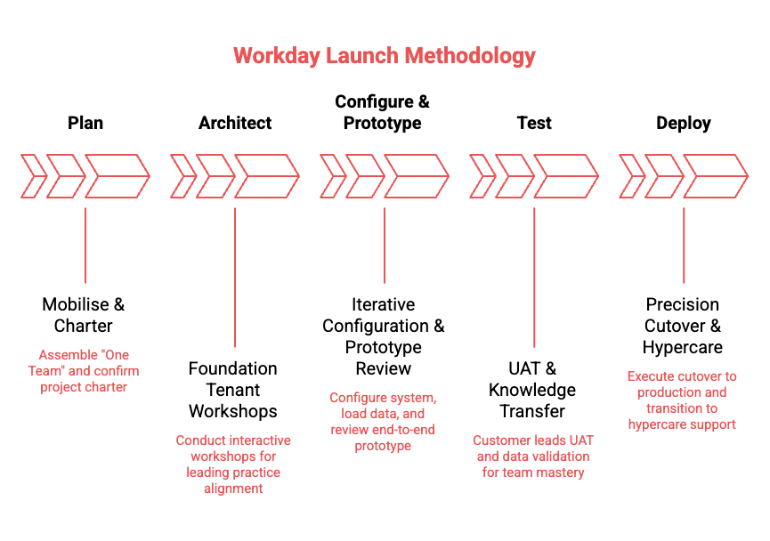
This model moves beyond the traditional "Client vs. Vendor" dynamic. We operate as a partnership where Mivada provides the methodology and configuration expertise, while Greenpeace provides the business context and data validation. This ensures that at Go-Live, your team owns a solution they already know how to operate.
Delivery Plan (Implementation Plan)
Mivada proposes a two-phase, configuration-led ERP implementation aligned to GPAP’s Digital Transformation Strategy and the indicative timeline outlined in the RFP.

Our approach prioritises:
- Rapid consolidation of core Finance, HCM and Payroll capabilities
- Early stabilisation of statutory and governance controls
- Seamless integration with Salesforce NPC and Data Cloud
- Structured enablement of advanced talent and budgeting capabilities in Phase 2
- Controlled risk through phased mobilisation and hypercare

Phase 1

Phase 1 focuses on establishing GPAP’s modern enterprise backbone, delivering essential workforce, payroll, and finance capabilities required to support day-to-day operations. This phase includes:
- Core HCM
- Absence
- Recruiting
- Payroll and
- Finance
  - Financial Accounting
  - Banking & Settlement
  - Customer Accounts
  - Supplier Accounts
Integrations in Scope (Phase 1)
- Salesforce NPC / Data Cloud Integration
- Weel Corporate Card Integration
These integrations will be delivered using an API-first architecture consistent with the RFP requirements.
As depicted in the diagram below, this phase is delivered end-to-end through design, build, testing, deployment, and post-go-live hypercare, ensuring system stability and user adoption before transitioning to the next stage.

Phase 2
Phase 2 introduces advanced capabilities that build on the established core platform. This phase includes:
- Talent & Performance Management
- Budgeting

The diagram below depicts the timeline for Phase 2:

Assumptions, Dependencies, and Exclusions.

- Governance & Decision Making
- Executive Sponsorship: The Client will appoint a dedicated Executive Sponsor who will serve as the ultimate decision-maker (Level 4 Escalation) and participate in the Strategic Governance (Steering Committee) forum to resolve blockers that threaten the relationship or critical path.
- Timely Decision Making: To maintain the project baseline, the Client agrees to provide binding decisions on design and configuration questions within 5 business days of the request. Failure to provide decisions within this timeframe will trigger a risk entry in the RAID Log and may require an Impact Assessment for timeline extension.
- Authority of Design Authority: The Client’s project team is empowered to make functional design decisions during workshops. If decisions made in workshops are later overturned by senior stakeholders not present, this will be treated as a scope change subject to an Impact Assessment.

- Commercial Rigour & Scope Management
- Impact Assessments vs. Change Requests: Any request to deviate from the agreed baseline requirements or standard configuration will be managed via a formal Impact Assessment. This assessment must be approved by the Mivada Engagement Manager before being presented to the client, ensuring commercial implications are validated prior to execution.
- Standard Functionality ("Fit-to-Standard"): The project estimates assume a "Fit-to-Standard" approach using out-of-the-box functionality. Any requirement for custom development, complex workarounds, or deviation from the standard SaaS methodology will be considered out of scope and subject to commercial negotiation.
- In Scope: The project scope is strictly limited to the modules and functional areas explicitly listed in the "In-Scope" section. Any item not explicitly listed is assumed to be Out-of-Scope, including undefined third-party integrations, legacy system decommissioning, or historical data archiving.

- Resource Availability & Dependency Management
- Client Resource Commitment: The Client guarantees the availability of Subject Matter Experts (SMEs) for all scheduled workshops, testing cycles, and data validation tasks.
- Dependency delays: Mivada is not liable for delays caused by the Client’s failure to complete prerequisite tasks (e.g., workbook, network access, legacy system extracts, testing, sign offs) by the agreed dates in the Project Schedule. Such delays will be logged in the RAID log and may incur wait-time costs.
- Single Point of Contact: The Client will provide a Project Manager or single point of contact responsible for coordinating internal client resources, room bookings, and internal scheduling to align with the Mivada delivery plan.

- Data Management (The RACI Standard)
- Data Cleansing Responsibility: The Client is accountable (Responsible) for the extraction, cleansing, and transformation of legacy data into the specific templates provided by Mivada. Mivada is Responsible only for the loading of this data into the new system.
- Data Quality: The project schedule assumes that data provided by the Client will be clean, valid, and reconciled prior to submission. Delays or reload cycles caused by corrupt, incomplete, or inaccurate legacy data will trigger a commercial Impact Assessment.
- History & Archiving: Unless explicitly scoped, the migration of historical transactional data is excluded. The implementation assumes a "balance forward" or "snapshot" approach for the go-live cutover.
- Testing & Validation
- Client Ownership of UAT: User Acceptance Testing (UAT) is a client-led activity. The Client is responsible for creating UAT test scenarios, writing test scripts, and executing tests. Mivada’s role during this phase is limited to "Level 2/3" support for defect resolution.
- Defect Classification: Testing entry and exit criteria will adhere to Mivada’s standard definition of Severity levels. Go-Live will not be delayed by cosmetic or Severity 3/4 (Low impact) defects that have viable workarounds.
- Environment Stability: The Client is responsible for ensuring any downstream systems or third-party vendors required for Integration Testing are available and stable during the scheduled testing windows.

- Transition & Hypercare
- Hypercare Exit Criteria: Post-deployment support (Hypercare) is limited to the fixed period defined in the SOW (e.g., 4 weeks). Continued support beyond this period requires a transition to a separate Application Management Services (AMS) contract or an extension via Impact Assessment.
- Knowledge Transfer: Mivada will provide knowledge transfer sessions to the Client’s system administrators as defined in the schedule. This does not constitute end-user training, which remains the responsibility of the Client’s Change Management team unless specifically purchased.

- Financial & Scheduling Baseline
- Baseline Schedule: The project timeline is based on a continuous delivery flow. Any "pause" or "hold" requested by the Client (e.g., for operational busy periods or holiday freezes) will require a re-baselining of the schedule and may incur team retention costs.
- Pre-Requisites: The project start date assumes that all necessary licenses, system environments, and remote access tokens are provisioned and accessible to the Mivada team on Day 1.

Proposed Governance and Team Structure

Governance Model
To maintain the velocity required for Workday Launch deployment, governance cannot be a bottleneck—it must be an enabler. We utilise a three-tiered governance structure designed to facilitate rapid decision-making and proactive risk management. This structure aligns with Greenpeace’s internal teams to ensure the "One Team" ecosystem remains synchronised, transparent, and focused on the Go-Live date. Each layer plays a distinct role in protecting the timeline and scope.
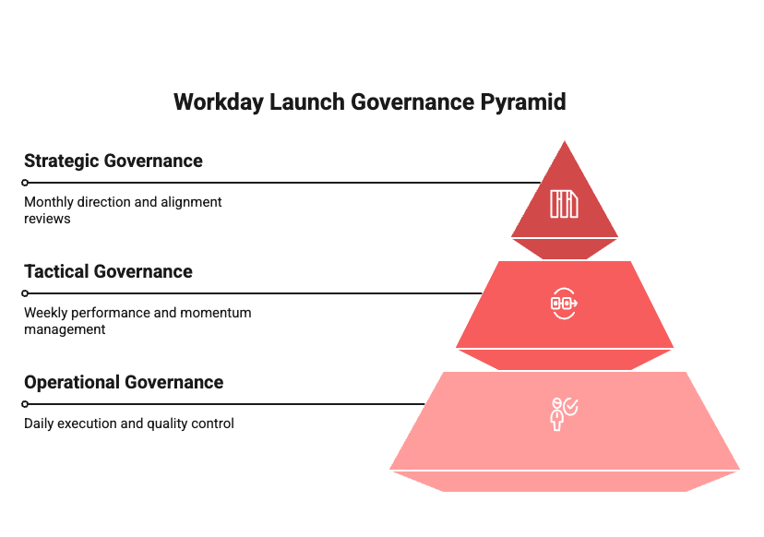
Strategic Governance (Steering Committee) - Monthly & Phase Gate Reviews
- Focus: Direction & Alignment This layer provides the "North Star" for the engagement. It ensures the project remains aligned with Greenpeace’s broader transformation goals and empowers the team to move past critical blockers.
- Monthly Steering Committee: Review of overall health, budget, and milestone progress.
- Phase Gate Sign-offs: Formal "Go/No-Go" decisions to move from Architect to Configure, or Test to Deploy.
- Executive Escalation: Resolution of strategic risks or scope changes that impact the timeline or budget.
Tactical Governance (Project Management) - Weekly Status & Planning
- Focus: Performance & Momentum, this layer manages the heartbeat of the project. It ensures that the operational plan is being executed effectively and that resources are unblocked.
- Weekly Status Reviews: Tracking progress against the Workday Launch roadmap.
- RAID Management: Active monitoring of Risks, Actions, Issues, and most critically in a Launch project - Decisions.
- Resource Planning: Ensuring the right Subject Matter Experts are available for upcoming workshops and testing cycles.
Operational Governance (Workstreams) - Daily Stand-ups & Ad-hoc Coordination
- Focus: Execution & Quality This layer manages the day-to-day "doing." It ensures that configuration, data, and testing activities are completed on time and to the leading practice standard.
- Daily Stand-ups: Quick synchronisation between Mivada consultants and Greenpeace leads to clear immediate blockers.
- Workshop & Sprint Execution: Collaborative sessions to review configuration and prototype data.
- Defect & Testing Management: During the Test phase, this shifts to daily triage of UAT findings and resolution planning.
- Knowledge Sharing: Continuous transfer of skills from Mivada experts to your internal team.

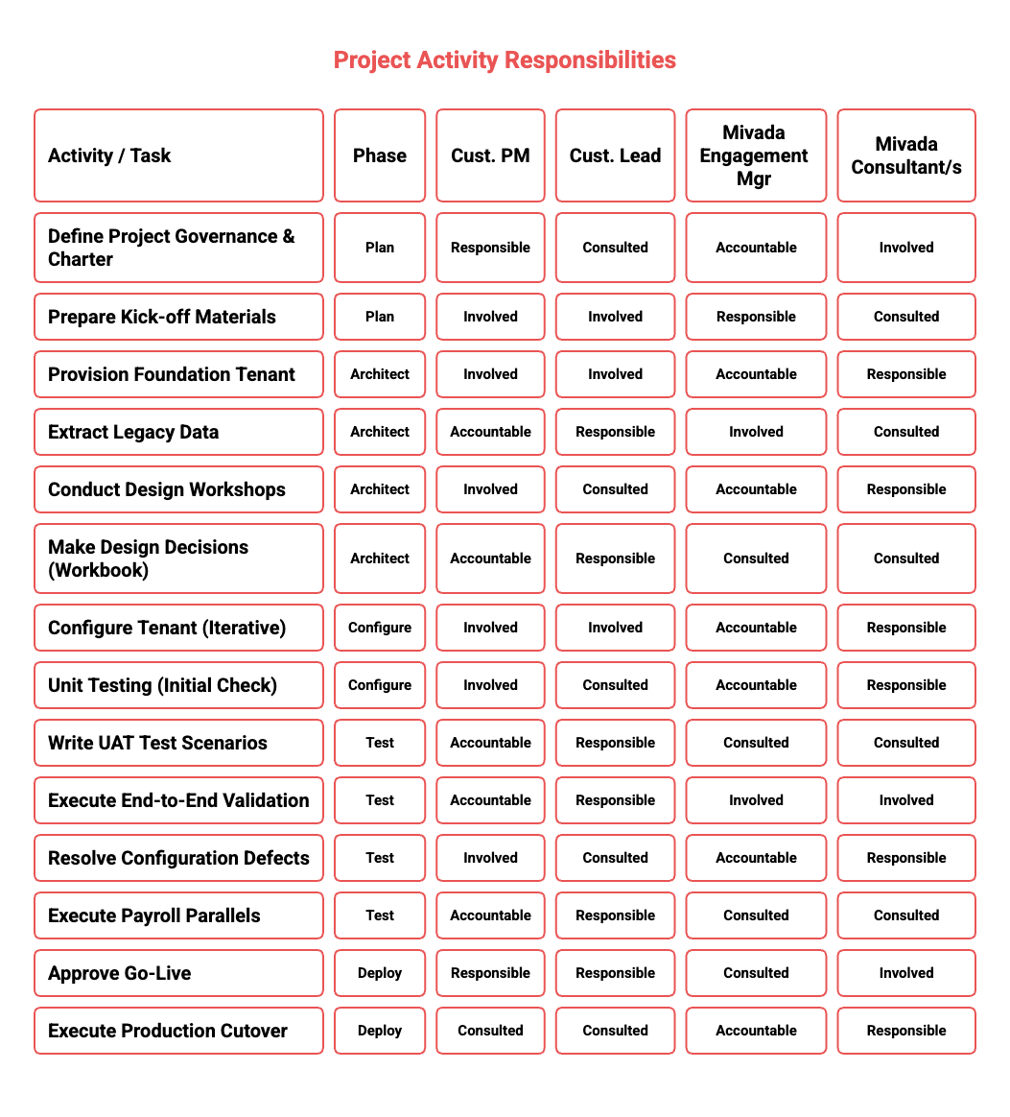
Roles and Responsibilities (Mivada and Greenpeace)

Velocity requires precision. To mitigate delivery risk and prevent bottlenecks, we have defined a clear Responsibility Assignment Matrix (RACI) for key project deliverables. This matrix ensures that Mivada’s technical expertise is perfectly synchronised with Greenpeace’s business insights.

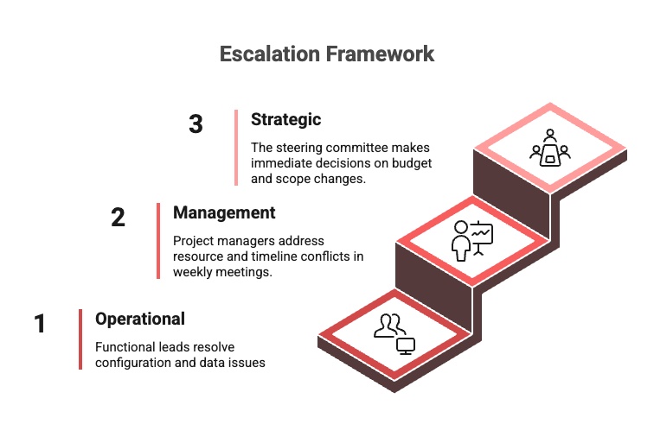
Escalation Mechanism

Mivada promotes a culture of "healthy escalation," where raising a hand for help is viewed as proactive project management rather than a sign of failure. Our framework is designed to bypass bottlenecks and ensure that decisions—the most common blocker in Launch projects—are made swiftly to protect the Go-Live date.

This approach integrates seamlessly with the Governance structure outlined above, creating a clear path from the operational workstreams up to the Steering Committee. Escalations are triggered not just by technical issues, but by any factor that threatens the critical path, such as resource unavailability, data delays, or decision latency.

The diagram below illustrates our tiered resolution path, ensuring that every blocker finds the right level of authority for a rapid solution.

RAID-D Management

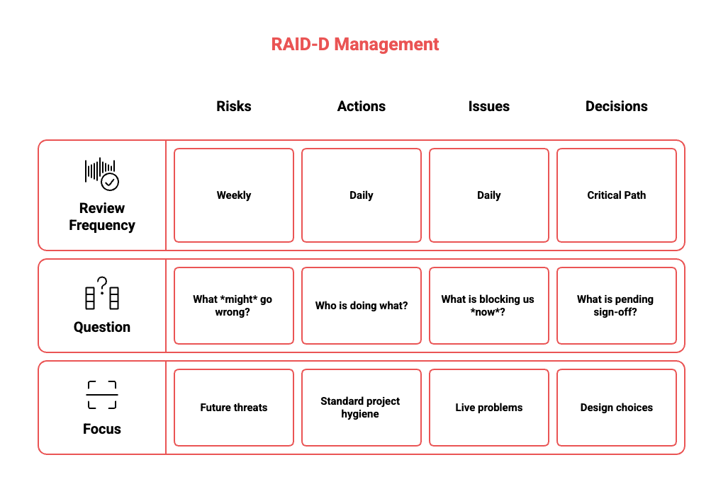
Standard methodology tracks Risks, Assumptions, Issues, and Dependencies (RAID). However, for a high-velocity Workday Launch, we expand this framework to RAID-D by adding a critical focus on Decisions.
In a compressed timeline, decision latency is the primary threat to the critical path. By separating Decisions from standard Issues and assigning them clear owners and deadlines, we ensure that design choices are made swiftly. The visual below highlights our four operational pillars for maintaining momentum.

Data migration strategy
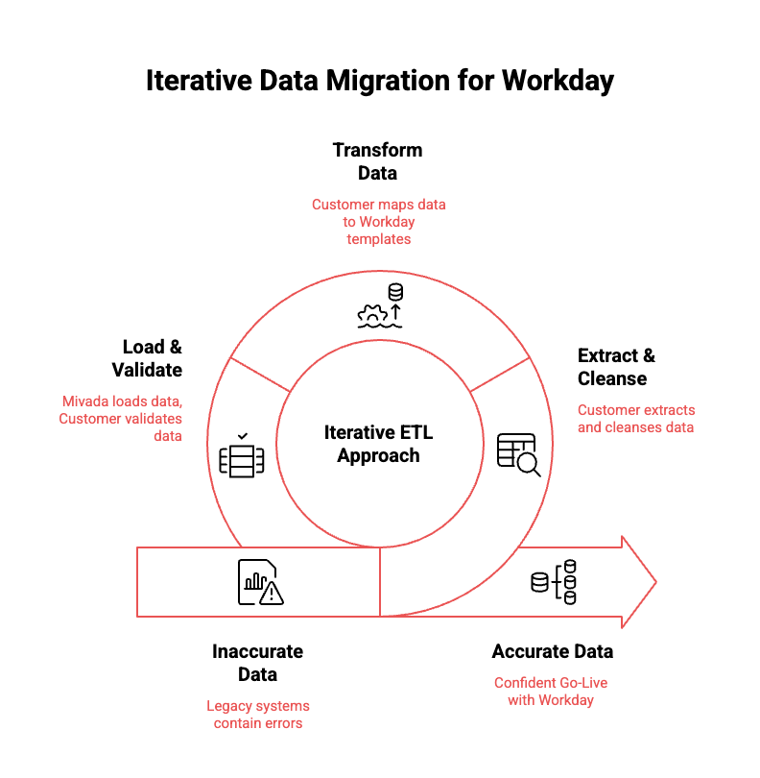
Data is the fuel for your Workday engine. A beautifully configured system offers little value if the underlying data is inaccurate or incomplete. Moving to the cloud is the perfect opportunity to leave "bad habits" behind and focus on quality over quantity.

To mitigate the risks typically associated with migration, Mivada employs a collaborative "Handshake Model" that plays to our respective strengths.

You Know Your Business (Extract & Cleanse): Greenpeace owns the extraction and cleansing of legacy data, ensuring only active, accurate records are migrated and transform to the provided templates.

We Know Workday (Templates & Load): Mivada provides the mapping templates and technical tools to load your data into Workday’s architecture.

Practice Makes Perfect: The Iterative Validation
We do not believe in a "big bang" approach where data is loaded once at the very end. Instead, our methodology treats migration as a series of rehearsals. We execute three distinct load cycles to build confidence, ensuring that by the time we reach the final cutover, the process feels routine rather than revolutionary:
- Foundation Load (P0): Early in the project, we load a subset of data to validate the structural configuration (e.g., Supervisory Organizations, Job Profiles).
- Testing Load (P1): We load your full data volume to support End-to-End testing. This allows your team to validate business processes using real, familiar people and numbers, not generic dummy data.
- Gold Load (Production): The final, cleansed dataset loaded during the cutover window for Go-Live.
- This partnership ensures that we aren't just moving data; we are refining it. By flushing out errors early in the P0 and P1 cycles, we ensure that on Day 1, your teams trust the numbers they see on the screen.

Team Structure
Mivada proposes a Delivery Team structure aligned to GPAP’s ERP implementation roadmap, governance framework, and phased rollout approach as outlined in the RFP. The team model is designed to ensure strong leadership, clear accountability, and access to specialist Workday expertise across each stage of delivery, while maintaining continuity and knowledge transfer throughout the project.

Dedicated Workday Practice and Thought Leadership
Mivada delivers this project through its dedicated Workday practice, comprising experienced consultants across HCM, Payroll, Financials, Integrations, Data, and Change. Our consultants bring deep Workday certification, hands-on implementation experience, and strong understanding of complex, regulated environments such as aged care.
In addition, Greenpeace benefits from Mivada’s Workday thought leadership, including access to leading practices, accelerators, reusable assets, and insights drawn from multiple Workday implementations. This ensures Greenpeace not only receives a compliant solution, but one that is future-ready, scalable, and aligned to Workday’s evolving roadmap.

Delivery Team Structure Overview
The diagram below illustrates the Proposed Delivery Team Structure, aligned to the phased implementation approach and governance requirements. The model demonstrates how Mivada will deploy a combination of project leadership, functional specialists, and technical experts across each phase to ensure clear accountability, continuity of knowledge, and access to deep Workday expertise throughout the lifecycle of the project.

The team structure reflects a Phased Resourcing Model, with core leadership retained across phases and specialist consultants introduced as required, enabling a controlled, scalable, and cost-effective delivery aligned to Greenpeace’s priorities.

The engagement will be led by a Client Partner, providing executive oversight, strategic alignment, and senior stakeholder engagement. Supporting this role is the Engagement Manager, responsible for overall delivery management, commercial oversight, risk mitigation, and program governance.
A Functional Lead will oversee solution design and functional alignment across all workstreams, ensuring consistency, best practice adoption, and adherence to agreed business outcomes.
Phase 1 focuses on foundational Workday capabilities. The Core HCM workstream includes consultants for Core HCM, Absence, and Recruitment. The Integration workstream is led by an Integration Lead supported by an Integration Consultant to manage integration strategy and system connectivity. Payroll and Finance capabilities are delivered by dedicated Payroll and Finance Consultants.
Phase 2 expands the solution to include Talent and Performance, as well as Budgeting, delivered by specialist consultants in these areas.
Mivada further strengthens the engagement through Workday thought leadership and a dedicated practice covering Payroll, Automation, new Workday features, and process optimisation, ensuring long-term value and continuous improvement.
Indicative CVs of Key Resources have been attached in Attachment: “Mivada_Indicative CVs for Greenpeace.pdf

Expectations for Greenpeace Project Team

A successful Workday Launch deployment relies on a unified approach. We do not view this engagement as a traditional vendor-client transaction; rather, we operate as a One Team Ecosystem with a shared commitment to the Go-Live date.
While Mivada brings the "Workday Launch" methodology and technical configuration expertise, Greenpeace provides the essential business context and decision-making power.

The successful delivery of the project is dependent on a strong, collaborative partnership underpinned by clearly defined roles, timely decision-making, and committed resourcing from both parties.

To support this outcome, Greenpeace is expected to allocate appropriately skilled resources across key project, business, and technical roles for the duration of the implementation. These resources will be responsible for providing business context, validating requirements and configurations, supporting data and testing activities, enabling change and training, and ensuring organisational readiness at go-live. Dedicated engagement from Greenpeace stakeholders will also ensure issues are resolved efficiently and project milestones are achieved in line with agreed timelines.

The diagram below outlines the proposed Greenpeace-side roles and indicative full-time equivalent (FTE) allocation required to support the implementation. The recommended FTE levels represent an average commitment across the project lifecycle. Actual effort will vary by phase, with certain roles requiring higher or lower weekly commitment at different stages of the project.

Commercials

Mivada proposes to deliver the defined Workday Implementation scope for Greenpeace on a Fixed Price basis.
Total Implementation Cost: AUD $249,000 (ex GST)

This Investment Includes the services detailed above.

Key Exclusions:
- Workday software subscription fees.
- Third-party system costs or integration middleware licensing.
- Travel and reasonable out-of-pocket expenses (billed at cost).

Ongoing Support and Managed Services (Optional)

Mivada offers Application Management Services (AMS) to support Greenpeace following go-live where additional support is required beyond the standard support provided by Workday. This service is designed to align with Greenpeace’s requirement for a stable and supportable HRIS operating model, while clearly defining the ongoing support responsibilities between Greenpeace, Workday, and Mivada.

The level of AMS support is agreed at commencement and is based on Greenpeace’s internal resourcing capability, governance preferences, and operational requirements, providing clarity and predictability around the ongoing support model.

Mivada’s AMS can include targeted functional or technical support or broader managed services, enabling Greenpeace to retain ownership of its HRIS while supplementing internal teams where additional capacity, specialist expertise, or continuity is required.

AMS services typically include incident, release and update support, integration monitoring, performance optimisation, and continuous improvement. This approach complements Workday’s standard support model by addressing configuration, integration, and operational scenarios that sit outside Workday’s direct support scope.

Commercially, AMS engagement levels are tailored to Greenpeace’s needs and may commence from approximately $7,500 AUD per month, subject to the agreed scope, level of support, and coverage required. Final sizing is determined based on Greenpeace’s internal resourcing model, desired level of self-sufficiency, and the areas where specialist support provides the greatest operational value.

Mivada welcomes a discussion with Greenpeace to confirm the appropriate AMS scope and engagement model, ensuring alignment with internal capability, governance expectations, and longer-term objectives for ownership and optimisation of the platform. The projected costs for ongoing support and managed services across three years are detailed below.

Year | Total Cost (AUD)
Year 1 | $90,000.00
Year 2 | $90,929.70
Year 3 | $91,869.00

